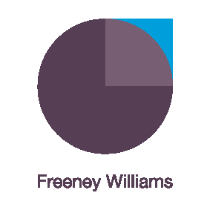
Having sensitive conversations in the new ways of working
This interactive, live workshop is limited to 15 participants and designed to develop participants’ confidence, skills, and tools, to be able to have those conversations which people find difficult at the best of times.
Working remotely and social distancing doesn’t mean avoiding difficult conversations whether to address staff members’ personal circumstances or performance.
This Zoom workshop will be delivered by Freeney Williams’ Director, Kerry Smith. Over 90 minutes, Kerry will address questions such as:
- What is a potentially sensitive conversation and when might one be appropriate?
- Is there a way to plan for a sensitive conversation which encourages a successful outcome?
- How should I structure an effective sensitive conversation?
- What type of techniques can I use during a sensitive conversation?
- How do I make sure that anything which is agreed during a sensitive conversation is actioned and successful?
The workshop will involve:
- Interactive engagement with Kerry Smith and other participants through discussion and text messaging within the Zoom app.
- Pre-workshop activity to facilitate initial discussions
- Supported by further reading
- Topic helpline provided by Kerry following the workshop
- One-to-one online coaching can also be arranged on request – ask for details
About Freeney Williams
Freeney Williams Ltd, led by Rick Williams, has 20 years’ experience of providing consultancy and training in issues around people’s emotional resilience and wellbeing.
More workshops will follow so keep an eye on our website for more information
For more information, please contact:
Rick Williams CFCIPD
rick@freeneywilliams.com
T: 01273 323949
M: 07788 448428

