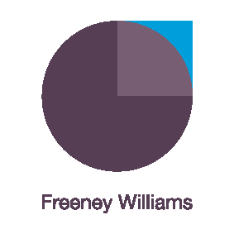
Unconscious bias and decision making arising from Covid-19
We all make decisions, judgements and assumptions about issues and people at work. Until now these were typically framed by our traditional ways of working. Our new ways of working require us to review such unconscious bias to ensure our judgements and decisions do not have a negative impact on individuals and groups when we apply our traditional perspectives.
This on-line workshop explores the relationship between the impact of Covid-19 and its associated new ways of working and the unconscious impact this could have on decision making and behaviours.
The interactive, live workshop is limited to 15 participants will be delivered by Freeney Williams’ Director of Consultancy, Clare Cromarty. Over 90 minutes, Clare will address questions such as:
- What is unconscious bias and what impact could it have on our teams, customers and other stakeholders?
- How could Covid-19 and the new ways of working and interacting with others impact upon the judgements and decisions we make?
- What strategies could we use to minimise the impact of unconscious bias on our judgements and decisions?
- How do we explore these issues with colleagues and other stakeholders?
The workshop will involve:
- Interactive engagement with Clare Cromarty and other participants through discussion and text messaging within the Zoom app.
- Pre-workshop activity to facilitate initial discussions
- Supported by further reading
- Topic helpline provided by Clare following the workshop
- One-to-one online coaching can also be arranged on request – ask for details
About Freeney Williams
Freeney Williams Ltd, led by Rick Williams, has 20 years’ experience of providing consultancy and training in issues around people’s emotional resilience and wellbeing.
More workshops will follow so keep an eye on our website for more information
For more information, please contact:
Rick Williams CFCIPD
rick@freeneywilliams.com
T: 01273 323949
M: 07788 448428

